**PREDICTIVE MAINTENANCE FOR INDUSTRIAL EQUIPMENT USING IOT DATA.**

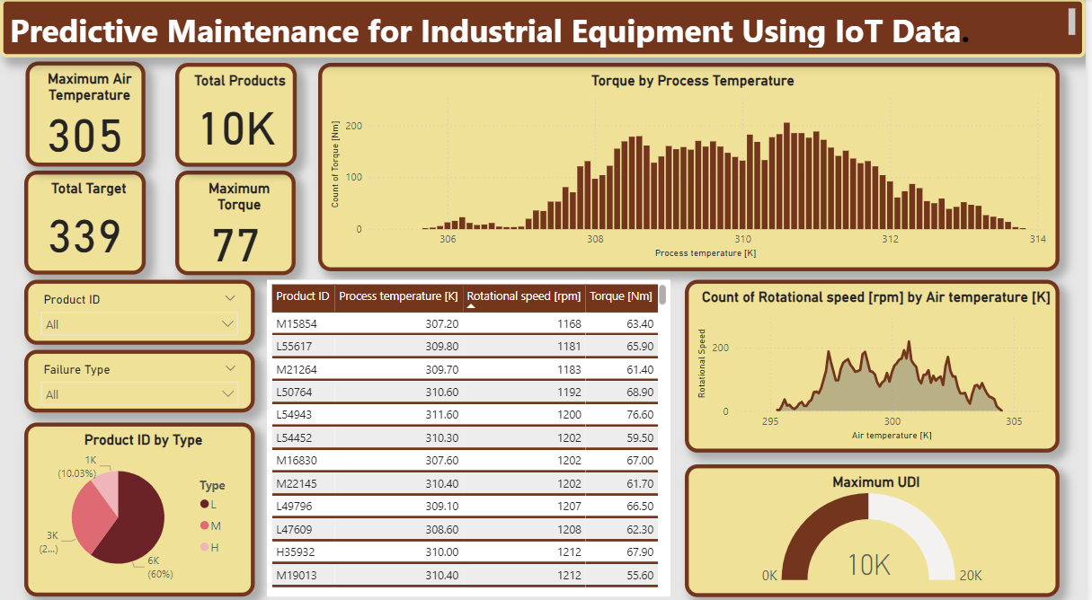

**OBJECTIVE:**

This dashboard provides insights into the operational data of industrial equipment, leveraging IoT data for predictive maintenance. It focuses on key parameters such as air temperature, process temperature, rotational speed, and torque to monitor the health and performance of equipment. The aim is to enable early detection of potential failures, optimize maintenance schedules, and reduce downtime.

**KEY METRICS:**

1. **Maximum Air Temperature:**
   * Value: **305 K**  
     This represents the highest recorded air temperature in the equipment environment.
2. **Total Products Monitored:**
   * Value: **10K**  
     A total of 10,000 products or equipment are being tracked for predictive maintenance purposes.
3. **Total Target:**
   * Value: **339**  
     Indicates the number of targets, likely representing equipment or units that require attention due to the risk of failure or maintenance needs.
4. **Maximum Torque:**
   * Value: **77 Nm**  
     This represents the highest torque recorded across all equipment.

**INSIGHTS AND RECOMMENDATIONS:**

* **Temperature and Torque Correlation:** The dashboard indicates a strong correlation between process temperature and torque, suggesting that temperature variations can significantly impact the torque performance of equipment. Monitoring this closely can help in early fault detection.
* **Rotational Speed Patterns:** There is a noticeable fluctuation in rotational speed based on air temperature. Anomalies in this pattern may signal potential issues with the equipment's cooling system or other air temperature-dependent components.
* **Preventive Maintenance Planning:** By tracking product ID, temperature, rotational speed, and torque, maintenance teams can prioritize equipment that shows signs of degradation or abnormal operation, improving the efficiency of maintenance schedules and minimizing unplanned downtime.

**CONCLUSION:**

This dashboard provides a comprehensive view of equipment health, utilizing IoT data for predictive maintenance. By analyzing key performance metrics such as temperature, rotational speed, and torque, it enables informed decision-making to prevent equipment failure, optimize operational efficiency, and reduce maintenance costs.